Robot V 1.20

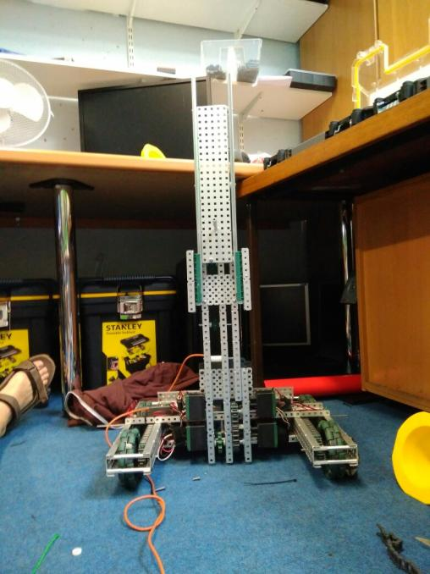

SPECIFICATIONS:

* 6 Motor HS drive
* Two drive chains
* 4 wheels
* Aluminium structure
* 4 motor lift
* Two stage lift

DIMENTIONS:

17.5” * 15” * 17.5 when not extended

**What needs to be changed:**

* Fix lift problem
* Add a claw

By Robbie Buxton

9/7/2017 – 12:55

**Overview:**

For this version of the robot we finally mounted the lift onto the base of our robot. After that we mounted the cortex and the power extender which we plugged the lift and drive into. We also finally got around to cable managing our robot. After switching everything on we found the robot was balanced well and the drive worked perfectly however the lift was having problems. We found the lift would go up perfectly however would jitter and shudder when going downwards. This is obviously a problem. We could not fix it today however we plan to work out what is causing the problem and fix it.

**WHAT HAS BEEN CHANGED:**

* Attached lift to base
* Added two more motors to lift
* Mounted cortex and power extender
* Wired up the robot